**Optional: Creating a Django project (steps and code)**

**Introduction**

This Reading will give you an overview of the steps to be taken while working with VS Code using pipenv as your virtual environment while creating a Django project. The project structure can be variable according to the learner preferences, but the one suggested can also be used for ease.

**Note:** The instructions in this reading may vary slightly from the instructions in the video about creating a Django project because the video presumes a preconfigured Pipfile.

**Note:** The commands added below are specific to MacOS. The learner will have to make OS specific changes such as using keyword **python** instead of **python3** for Windows OS.

**Step 1**

Open VS Code on your computer and click on **File**. In the drop-down menu select **Open Folder** and select the folder you have created for the project.

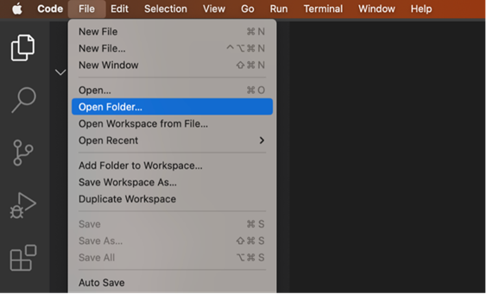

Now click on **Terminal** and select **New Terminal** from the drop-down menu. This is the main folder that contains all your files for the Django project you are going to create.

**Step 2**

Create a directory for the Django project by running the following command:

**mkdir LittleLemon**

**Step 3**

Step inside the LittleLemon directory with the command:

**cd LittleLemon**

**Step 4**

Run the following command to create a project in this directory:

**django-admin startproject BookList .**

**Step 5**

Run a command to activate **pipenv**:

**pipenv shell**

**Note:** It is expected that pipenv is installed using pip in your local machine.

**Step 6**

Open the file labeled **Pipfile** that was created inside the project directory. This file contains details of the dependencies for the project. Update it with the following code and save the file.

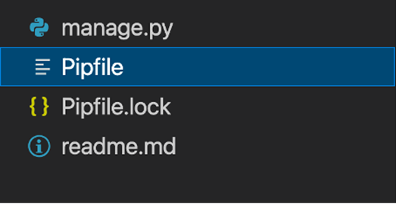

**Step 7**

Run this command to install the dependencies using the updated **Pipfile**:

**pipenv install**

**Note:** Alternatively, you can also use commands such as **pipenv install django** to install specific packages. This will also update the Pipfile.

**Step 8**

Now run this command to create a Django app:

**python3 manage.py startapp LittleLemonDRF**

**Step 9**

Run the command to start the server to test if the installation was successful.

**python3 manage.py runserver**

Stop the server by pressing **Ctrl** + **C** while you are in the Terminal window.

**Step 10**

Create the **urls.py** file in the app-level **LittleLemonDRF** directory.

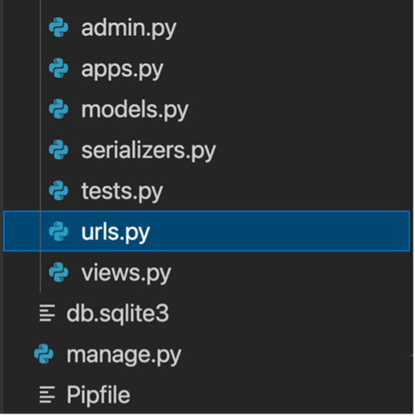

Paste the following code inside it:

**Note: The specific url configurations will differ according to the views created**

**Step 11**

Open the **urls.py** file in the project-level directory and update the code as follow:

**Note:** The specific url configurations at the project-level will vary according to the name of the app created.

**Concluding Thoughts**

In this reading, you learnt about the initial setup you need to make on your local machine while running VS Code with pipenv for creating a Django project.